NAME : Shri Harshini Devi . A
REG.NO : 192524104
Dept. Name : B.Tech -AIDS
Course Code/Course Name: DSA06 /Data Handling and Visualization
Date: 20/07/2026

Unit II - Class Activity 1

1) Hospital Patient Admission Analysis (K5 Level)
Scenario:
A hospital has collected patient admission data for multiple departments (Cardiology, Neurology, Pediatrics, Orthopedics, Emergency) over the past year. Different visualization techniques are available to analyze the data.
Evaluation of Visualizations
Visualization | Purpose | Advantages | Limitations
Bar Chart | Compare total admissions across departments | Easy to understand; clearly shows department workload | Does not show distribution or variability
Stacked Bar Chart | Compare admissions by department and month | Shows total admissions and monthly contribution simultaneously | Difficult to compare individual monthly values accurately
Treemap | Display proportion of admissions by department | Efficiently shows relative size of each department | Exact comparisons between departments are difficult
Box Plot | Analyze admission variability | Displays median, quartiles, spread, and outliers; identifies consistency of admissions | Does not show total admission counts
Histogram | Show frequency distribution of admission counts | Reveals distribution pattern (normal, skewed, etc.) | Cannot compare departments directly
Best Visualization for Each Objective
- Department Workload: ✅ Bar Chart
  - Clearly compares the total number of admissions in each department.
  - Easy to identify the busiest and least busy departments.
- Admission Variability: ✅ Box Plot
  - Shows variation in admissions over time.
  - Detects outliers and consistency among departments.
- Patient Distribution: ✅ Treemap
  - Displays the proportion of admissions contributed by each department.
  - Provides an intuitive overview of patient distribution.
Justification
- Bar Chart is the most effective for measuring department workload because bar lengths allow quick comparison of total admissions.
- Box Plot is ideal for admission variability as it summarizes spread, median, and outliers, helping identify departments with fluctuating patient loads.
- Treemap effectively represents patient distribution by showing each department's share of total admissions through area.
- Although Stacked Bar Charts provide monthly breakdowns and Histograms show frequency distributions, they are less effective for directly communicating workload and variability across departments.
Conclusion
The most effective visualization depends on the analysis objective:
- 📊 Bar Chart → Best for Department Workload
- 📦 Box Plot → Best for Admission Variability
- 🟩 Treemap → Best for Patient Distribution
Using these three visualizations together provides a comprehensive understanding of hospital admissions, enabling administrators to allocate resources efficiently and improve patient care.

Below is a simple R program using ggplot2 and dplyr to create all the required visualizations.
1. Install and Load Libraries
# Install packages (run once)
install.packages("ggplot2")
install.packages("dplyr")
install.packages("treemap")

# Load libraries
library(ggplot2)
library(dplyr)
library(treemap)
2. Create Sample Dataset
# Hospital Patient Admission Data

hospital <- data.frame(
Department = c("Cardiology","Neurology","Pediatrics","Orthopedics","Emergency"),
Admissions = c(320,250,410,280,500)
)

print(hospital)

3. Bar Chart (Department Workload)
ggplot(hospital, aes(x = Department, y = Admissions, fill = Department)) +
geom_bar(stat = "identity") +
labs(title = "Hospital Patient Admissions by Department",
x = "Department",
y = "Number of Admissions") +
theme_minimal()

4. Stacked Bar Chart
# Sample monthly data
monthly <- data.frame(
Month = rep(c("Jan","Feb","Mar"), each = 5),
Department = rep(c("Cardiology","Neurology","Pediatrics",
"Orthopedics","Emergency"), 3),
Admissions = c(100,80,120,90,150,
110,85,140,95,170,
110,85,150,95,180)
)

ggplot(monthly, aes(x = Month, y = Admissions, fill = Department)) +
geom_bar(stat = "identity") +
labs(title = "Monthly Patient Admissions",
x = "Month",
y = "Admissions") +
theme_minimal()

5. Treemap (Patient Distribution)
treemap(
hospital,
index = "Department",
vSize = "Admissions",
title = "Patient Distribution by Department"
)

6. Box Plot (Admission Variability)
# Sample weekly admissions
boxdata <- data.frame(
Department = rep(c("Cardiology","Neurology","Pediatrics",
"Orthopedics","Emergency"), each = 5),
Admissions = c(60,65,70,68,62,
45,50,55,48,52,
75,80,85,78,82,
55,60,62,58,61,
95,100,105,98,102)
)

ggplot(boxdata, aes(x = Department, y = Admissions, fill = Department)) +
geom_boxplot() +
labs(title = "Admission Variability by Department",
x = "Department",
y = "Admissions") +
theme_minimal()

7. Histogram (Admission Distribution)
ggplot(boxdata, aes(x = Admissions)) +
geom_histogram(binwidth = 5, fill = "skyblue", color = "black") +
labs(title = "Distribution of Patient Admissions",
x = "Admissions",
y = "Frequency") +
theme_minimal()
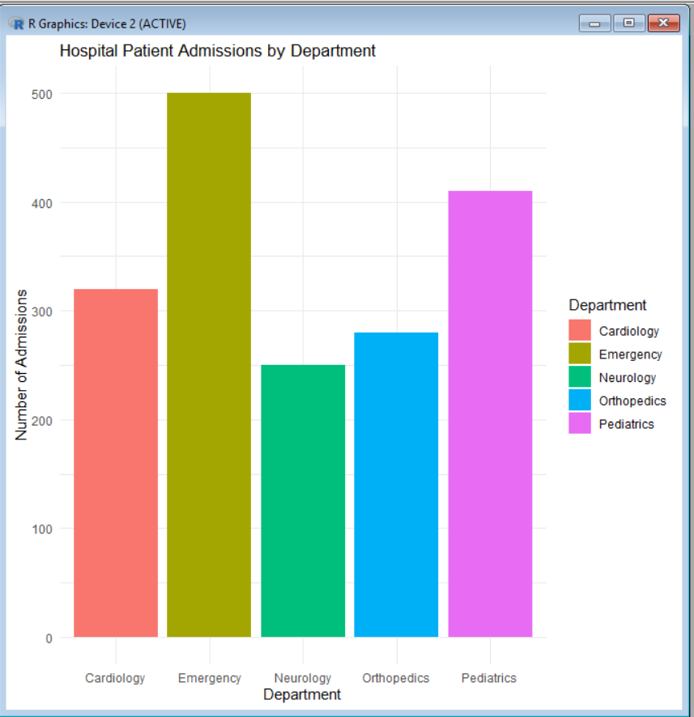

2) R Programming Code – E-Commerce Customer Spending Behaviour
1. Install and Load Libraries
# Install packages (Run once)
install.packages("ggplot2")

# Load library
library(ggplot2)

2. Create Sample Dataset
# Customer Spending Data

customer <- data.frame(
CustomerID = 1:15,
PurchaseAmount = c(120,250,80,300,450,150,600,220,500,350,100,700,400,270,550),
OrderFrequency = c(2,5,1,6,8,3,10,4,9,7,2,12,8,5,11),
Category = c("Electronics","Clothing","Books","Electronics","Home",
"Books","Electronics","Clothing","Home","Electronics",
"Books","Home","Clothing","Books","Electronics")
)

print(customer)

3. Histogram (Purchase Amount Distribution)
ggplot(customer, aes(x = PurchaseAmount)) +
geom_histogram(binwidth = 100, fill = "skyblue", color = "black") +
labs(title = "Distribution of Purchase Amount",
x = "Purchase Amount",
y = "Frequency") +
theme_minimal()

4. Violin Plot (Spending by Product Category)
ggplot(customer, aes(x = Category, y = PurchaseAmount, fill = Category)) +
geom_violin(trim = FALSE) +
labs(title = "Purchase Amount by Category",
x = "Product Category",
y = "Purchase Amount") +
theme_minimal()

5. Box Plot (Spending Variability)
ggplot(customer, aes(x = Category, y = PurchaseAmount, fill = Category)) +
geom_boxplot() +
labs(title = "Spending Variability by Category",
x = "Product Category",
y = "Purchase Amount") +
theme_minimal()

6. Density Plot (Purchase Amount Density)
ggplot(customer, aes(x = PurchaseAmount)) +
geom_density(fill = "lightgreen", alpha = 0.5) +
labs(title = "Density Plot of Purchase Amount",
x = "Purchase Amount",
y = "Density") +
theme_minimal()

7. Bar Chart (Average Spending by Category)
ggplot(customer, aes(x = Category, y = PurchaseAmount, fill = Category)) +
stat_summary(fun = mean, geom = "bar") +
labs(title = "Average Purchase Amount by Category",
x = "Product Category",
y = "Average Purchase Amount") +
theme_minimal()

Evaluation
Visualization | Best Use | Reason
Histogram | Spending Distribution | Shows how purchase amounts are distributed.
Violin Plot | Spending Pattern | Displays distribution shape and spread across categories.
Box Plot | Spending Variability | Identifies median, spread, and high-value customers (outliers).
Density Plot | Purchasing Trends | Shows the overall spending trend smoothly.
Bar Chart | Category Comparison | Compares average spending across product categories.
Recommendation for Business Executives
- 💰 High-Value Customers: Box Plot (clearly identifies outliers with very high spending).
- 📊 Spending Variability: Violin Plot (shows the full distribution and variability).
- 📈 Purchasing Trends: Density Plot (reveals overall spending patterns).
- 📋 Best Visualization for Executives: Bar Chart because it is simple, easy to interpret, and quickly compares average spending across product categories for informed business decisions.
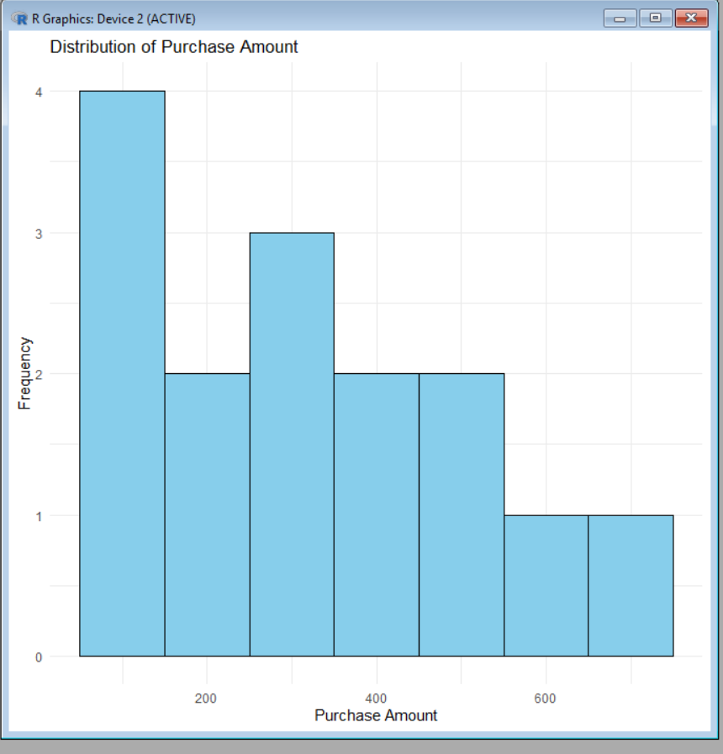

3) R Programming Code – University Examination Performance Dashboard
1. Install and Load Library
# Install package (Run once)
install.packages("ggplot2")

# Load library
library(ggplot2)

2. Create Sample Dataset
# University Examination Data

exam <- data.frame(
Department = c("CSE","ECE","EEE","MECH","CIVIL",
"CSE","ECE","EEE","MECH","CIVIL"),
Class = c("A","A","A","A","A","B","B","B","B","B"),
Marks = c(88,75,82,68,70,92,80,85,72,78)
)

print(exam)

3. Bar Chart (Average Marks by Department)
ggplot(exam, aes(x = Department, y = Marks, fill = Department)) +
stat_summary(fun = mean, geom = "bar") +
labs(title = "Average Marks by Department",
x = "Department",
y = "Average Marks") +
theme_minimal()

4. Box Plot (Marks Distribution & Outliers)
ggplot(exam, aes(x = Department, y = Marks, fill = Department)) +
geom_boxplot() +
labs(title = "Marks Distribution by Department",
x = "Department",
y = "Marks") +
theme_minimal()

5. Histogram (Score Distribution)
ggplot(exam, aes(x = Marks)) +
geom_histogram(binwidth = 5, fill = "skyblue", color = "black") +
labs(title = "Distribution of Student Marks",
x = "Marks",
y = "Frequency") +
theme_minimal()

6. Violin Plot (Marks Spread)
ggplot(exam, aes(x = Department, y = Marks, fill = Department)) +
geom_violin(trim = FALSE) +
labs(title = "Marks Spread by Department",
x = "Department",
y = "Marks") +
theme_minimal()

7. Scatter Plot (Top-Performing Classes)
ggplot(exam, aes(x = Class, y = Marks, color = Department)) +
geom_point(size = 3) +
labs(title = "Student Marks by Class",
x = "Class",
y = "Marks") +
theme_minimal()

Evaluation
Visualization | Purpose | Evaluation
Bar Chart | Compare average marks | Best for comparing department performance.
Box Plot | Identify score distribution and outliers | Clearly shows median, spread, and outliers.
Histogram | View overall mark distribution | Shows whether marks are normally distributed or skewed.
Violin Plot | Analyze score distribution | Displays the density and spread of marks.
Scatter Plot | Compare class-wise performance | Helps identify top-performing classes and individual high scorers.

Recommendation
- 📊 Department Comparison: Bar Chart
- 📦 Score Distribution & Outliers: Box Plot
- 📈 Overall Marks Distribution: Histogram
- 🎻 Marks Spread: Violin Plot
- 🎯 Top-Performing Classes: Scatter Plot
Dashboard Improvements
- Add Department and Class filters.
- Include KPI cards for Average Marks, Highest Marks, and Pass Percentage.
- Add tooltips to display student details on hover.
- Use color coding to distinguish departments.
- Arrange the dashboard with the Bar Chart at the top, Box Plot and Histogram in the middle, and the Scatter Plot at the bottom for better readability.
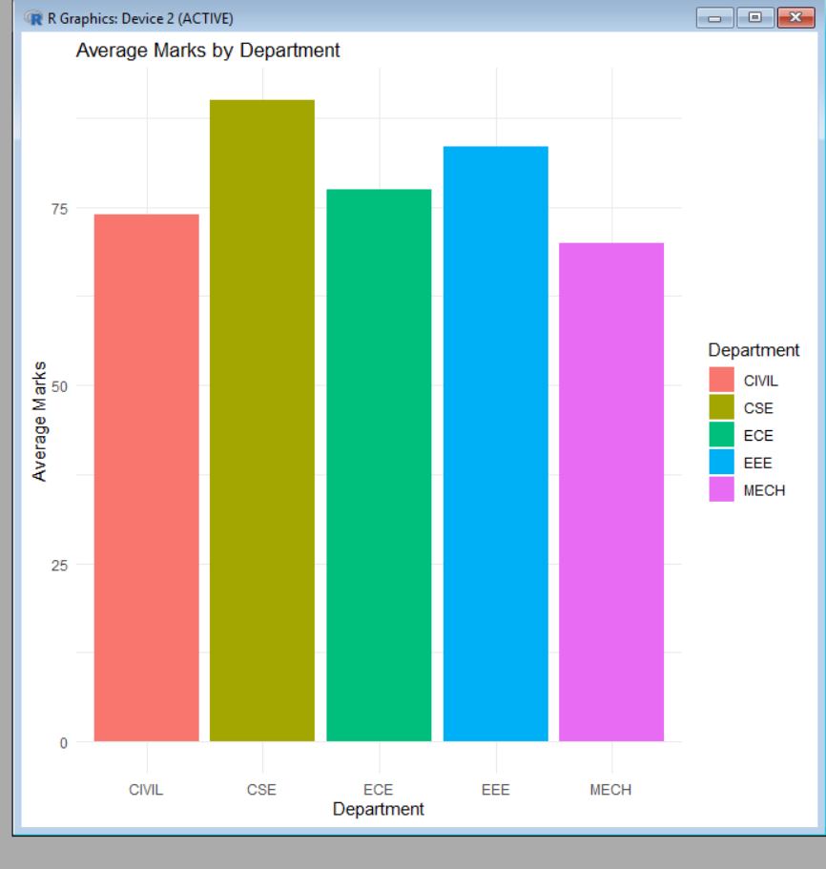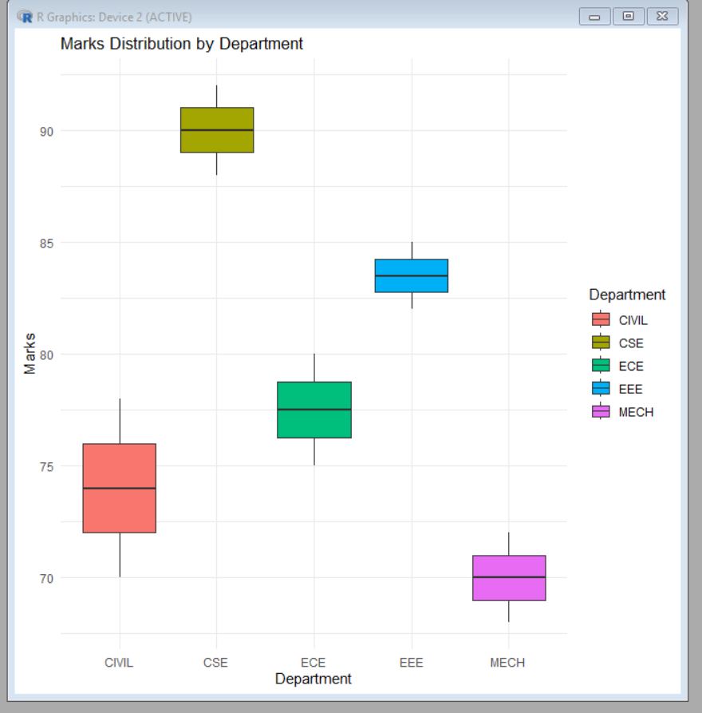

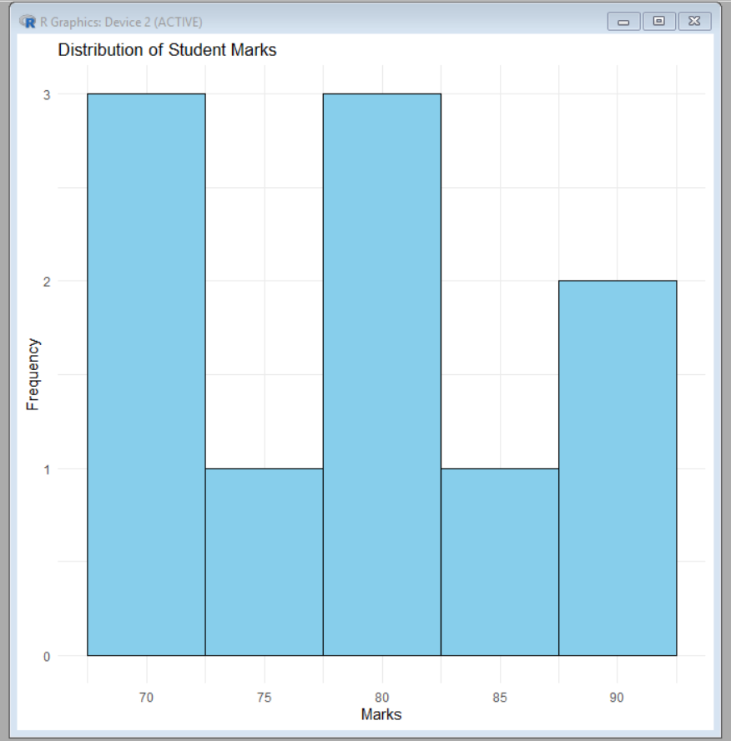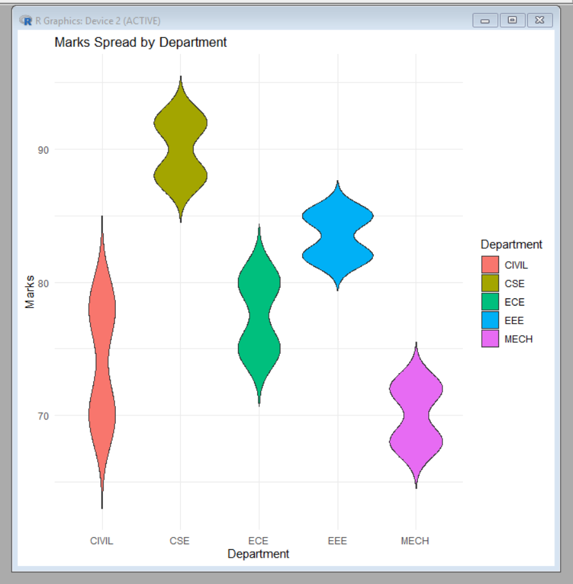

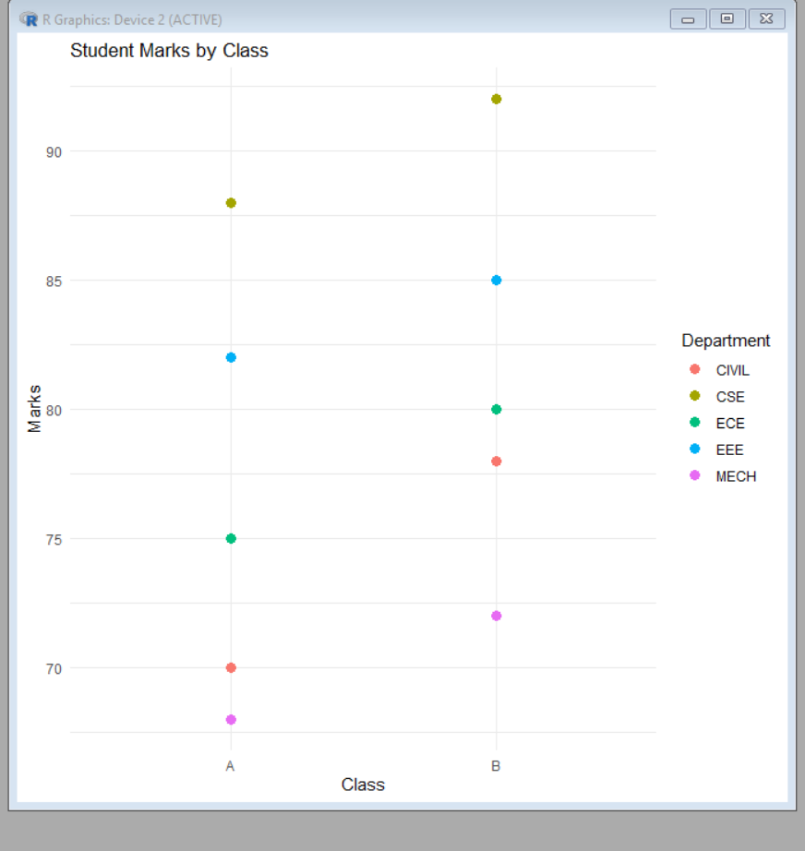

4) R Programming Code – Climate and Rainfall Distribution Study
1. Install and Load Library
# Install package (Run once)
install.packages("ggplot2")

# Load library
library(ggplot2)

2. Create Sample Dataset
# Climate Data

climate <- data.frame(
City = c("Chennai","Mumbai","Delhi","Kolkata","Bangalore",
"Chennai","Mumbai","Delhi","Kolkata","Bangalore"),
Month = c("Jan","Jan","Jan","Jan","Jan",
"Jul","Jul","Jul","Jul","Jul"),
Rainfall = c(20,15,10,25,30,180,250,150,220,160),
Temperature = c(28,26,18,22,24,30,29,35,32,27),
Humidity = c(65,70,55,68,60,85,90,75,88,80)
)

print(climate)

3. Histogram (Rainfall Distribution)
ggplot(climate, aes(x = Rainfall)) +
geom_histogram(binwidth = 30, fill = "skyblue", color = "black") +
labs(title = "Distribution of Rainfall",
x = "Rainfall (mm)",
y = "Frequency") +
theme_minimal()

4. Density Plot (Rainfall Density)
ggplot(climate, aes(x = Rainfall)) +
geom_density(fill = "lightgreen", alpha = 0.5) +
labs(title = "Rainfall Density Plot",
x = "Rainfall (mm)",
y = "Density") +
theme_minimal()

5. Box Plot (Rainfall Variation by City)
ggplot(climate, aes(x = City, y = Rainfall, fill = City)) +
geom_boxplot() +
labs(title = "Rainfall Variation by City",
x = "City",
y = "Rainfall (mm)") +
theme_minimal()

6. Bar Chart (Average Rainfall by City)
ggplot(climate, aes(x = City, y = Rainfall, fill = City)) +
stat_summary(fun = mean, geom = "bar") +
labs(title = "Average Rainfall by City",
x = "City",
y = "Average Rainfall (mm)") +
theme_minimal()

Evaluation
Visualization | Purpose | Evaluation
Histogram | Rainfall Distribution | Shows frequency of rainfall values across observations.
Density Plot | Climate Distribution | Displays the overall rainfall pattern smoothly.
Box Plot | Seasonal Variation | Identifies spread, median, and outliers in rainfall among cities.
Bar Chart | Average Rainfall Comparison | Compares average rainfall across different cities.

Comparison of Three Visualizations
- Histogram
  - Best for understanding rainfall frequency.
  - Does not compare cities directly.
- Density Plot
  - Best for identifying rainfall distribution patterns.
  - Smoother than a histogram but less effective for city-wise comparison.
- Box Plot
  - Best for seasonal rainfall variation.
  - Clearly shows median, variability, and outliers for each city.

Recommendation
- 🌧 Seasonal Rainfall Variation: Box Plot
- 📈 Climate Distribution: Density Plot
- 📊 Average Rainfall Comparison: Bar Chart
Most Suitable Visualization for Environmental Researchers
Box Plot is the most suitable because it:
- Clearly shows seasonal rainfall variation.
- Detects extreme rainfall (outliers).
- Compares variability across multiple cities.
- Supports better climate and environmental analysis than the other visualizations.
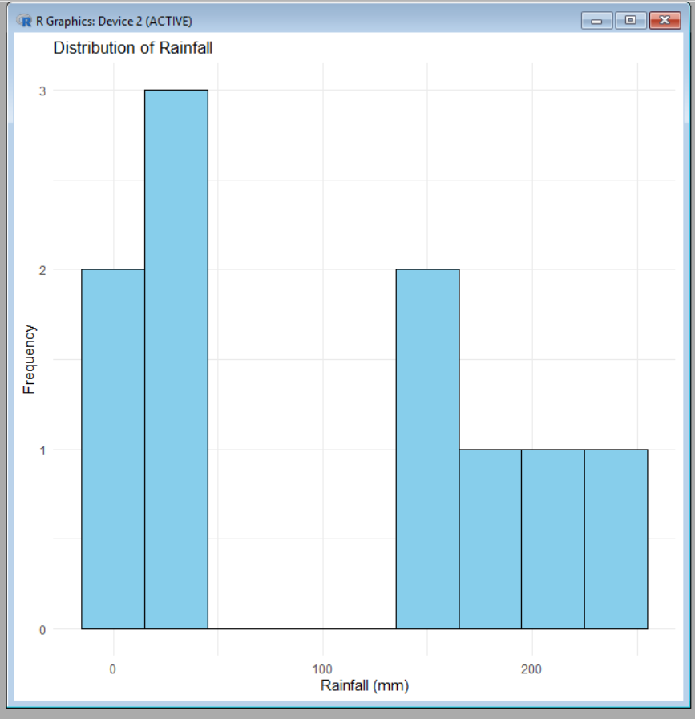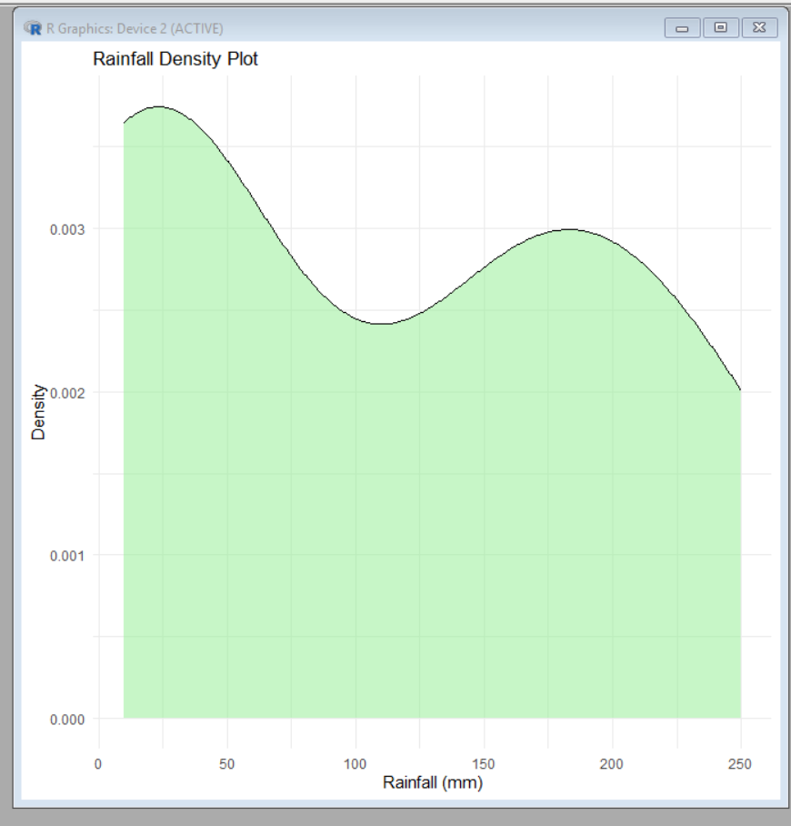

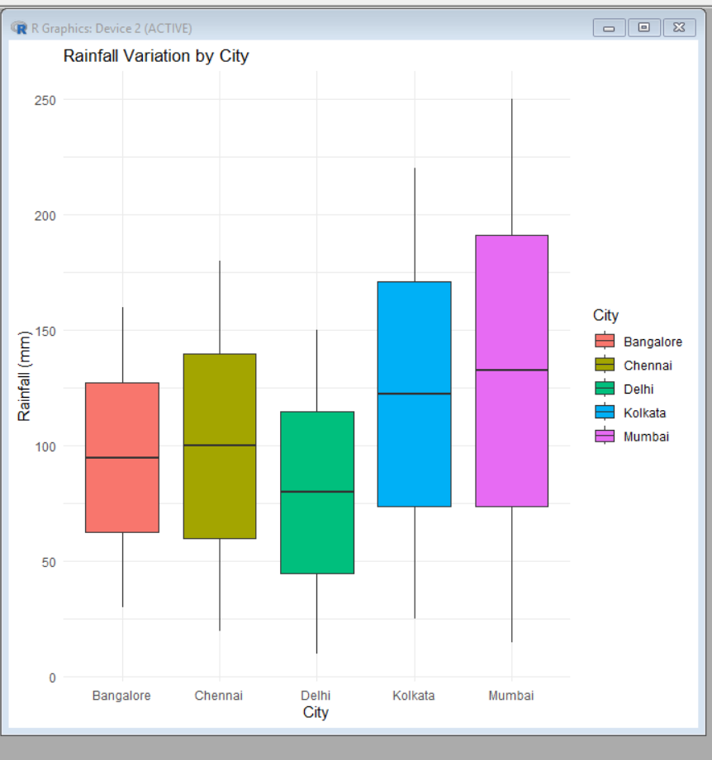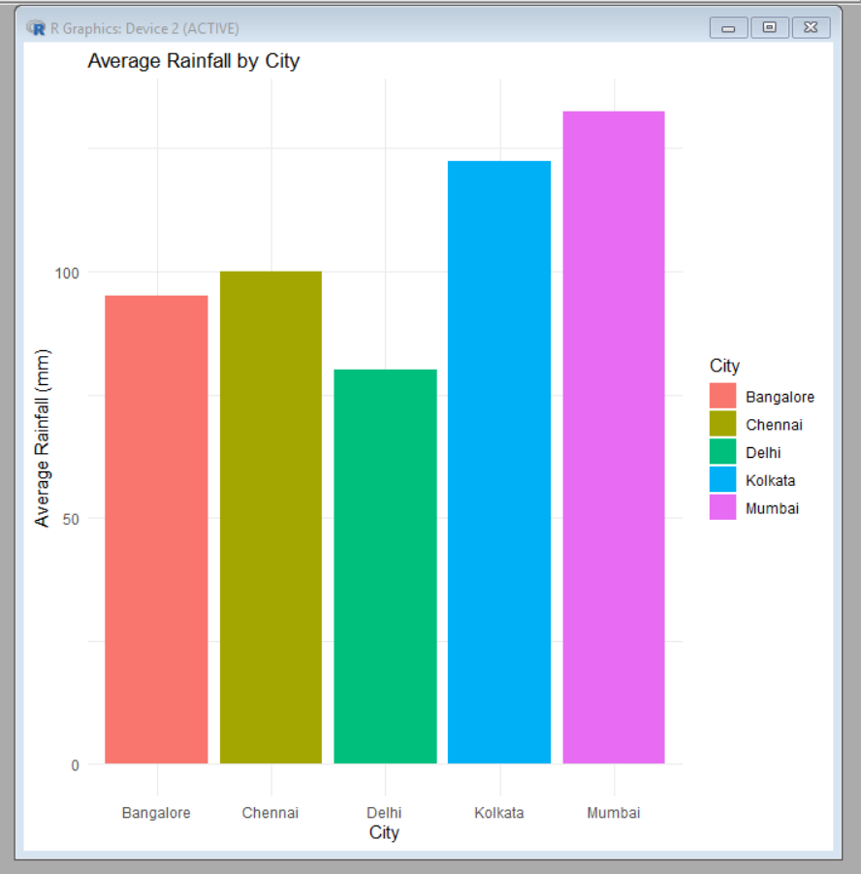

5)R Programming Code – Bank Loan Risk Assessment
1. Install and Load Library
# Install package (Run once)
install.packages("ggplot2")

# Load library
library(ggplot2)

2. Create Sample Dataset
# Bank Loan Data

loan <- data.frame(
CustomerID = 1:10,
LoanAmount = c(200000,350000,150000,500000,250000,
450000,300000,600000,180000,400000),
Income = c(50000,70000,40000,90000,60000,
85000,65000,100000,45000,75000),
CreditScore = c(750,680,620,800,710,
770,690,820,640,730),
Repayment = c("Good","Average","Poor","Good","Good",
"Average","Poor","Good","Poor","Average")
)

print(loan)

3. Histogram (Loan Amount Distribution)
ggplot(loan, aes(x = LoanAmount)) +
geom_histogram(binwidth = 50000, fill = "skyblue", color = "black") +
labs(title = "Loan Amount Distribution",
x = "Loan Amount",
y = "Frequency") +
theme_minimal()

4. Box Plot (Loan Amount by Repayment History)
ggplot(loan, aes(x = Repayment, y = LoanAmount, fill = Repayment)) +
geom_boxplot() +
labs(title = "Loan Amount by Repayment History",
x = "Repayment History",
y = "Loan Amount") +
theme_minimal()

5. Bar Chart (Average Credit Score by Repayment)
ggplot(loan, aes(x = Repayment, y = CreditScore, fill = Repayment)) +
stat_summary(fun = mean, geom = "bar") +
labs(title = "Average Credit Score by Repayment History",
x = "Repayment History",
y = "Average Credit Score") +
theme_minimal()

6. Scatter Plot (Income vs Loan Amount)
ggplot(loan, aes(x = Income, y = LoanAmount, color = Repayment)) +
geom_point(size = 3) +
labs(title = "Income vs Loan Amount",
x = "Income",
y = "Loan Amount") +
theme_minimal()

7. Density Plot (Credit Score Distribution)
ggplot(loan, aes(x = CreditScore)) +
geom_density(fill = "lightgreen", alpha = 0.5) +
labs(title = "Credit Score Distribution",
x = "Credit Score",
y = "Density") +
theme_minimal()

Evaluation
Visualization | Purpose | Evaluation
Histogram | Loan amount distribution | Shows the distribution and skewness of loan amounts.
Box Plot | Risk analysis | Identifies outliers and repayment risk patterns.
Bar Chart | Customer segments | Compares average credit scores by repayment history.
Scatter Plot | Income vs Loan | Shows the relationship between income and loan amount.
Density Plot | Credit score distribution | Displays the overall distribution of customer credit scores.

Recommendation
- 💰 Loan Distribution: Histogram
- ⚠️ Risk Patterns & Outliers: Box Plot
- 👥 Customer Segments: Bar Chart
- 📈 Income vs Loan Relationship: Scatter Plot
- 📊 Credit Score Distribution: Density Plot
Best Visualization for Management Dashboard
Box Plot is the most suitable because it:
- Clearly identifies high-risk customers through outliers.
- Highlights repayment variability.
- Supports better loan approval decisions by comparing repayment groups.
- Provides quick insights into customer risk patterns for management.
